Narural Language Processing Learning
MINI-PROJECT REPORT

ON

“VerifAI - Fake News Detection”

BY

Rajashekhar Maduri (A-763)

Pratham Kothari (A-766)

Swaraj Dudhmal (A-779)
Ashish Dhadekar (A-771)

Under the guidance of

Internal Guide
Prof. Suresh Mestry


Juhu-Versova Link Road Versova, Andheri(W), Mumbai-53
Department of Computer Engineering
University of Mumbai

Oct- 2026

Declaration

We wish to state that the work embodied in this project titled “VerifAI - Fake News Detection” forms our own contribution to the work carried out under the guidance of “Prof. Suresh Mestry at the Rajiv Gandhi Institute of Technology.
I declare that this written submission represents my ideas in my own words and where others' ideas or words have been included, I have adequately cited and referenced the original sources. I also declare that I have adhered to all principles of academic honesty and integrity and have not misrepresented or fabricated or falsified any idea/data/fact/source in my submission. I understand that any violation of the above will be cause for disciplinary action by the Institute and can also evoke penal action from the sources which have thus not been properly cited or from whom proper permission has not been taken when needed.

(Students Signatures)

Rajashekhar Maduri (A-763) ___________________________

Pratham Kothari (A-766) ___________________________

Swaraj Dudhmal (A-779) __________________________

Ashish Dhadekar (A-771) _________________________

Abstract

The rapid growth of online platforms has amplified the circulation of misinformation, commonly known as fake news. Such content spreads quickly across social media and digital outlets, often misleading readers and creating societal challenges. Addressing this issue requires automated systems capable of efficiently analyzing text and distinguishing between real and fake information.
VerifAI is a Fake News Detection system developed using Natural Language Processing (NLP) techniques. The system processes news headlines with optional context, converts them into TF-IDF vectorized features, and classifies the input as Real or Fake. To improve transparency, the system integrates LIME explainability, which highlights key words that influence each prediction.
The system achieved an accuracy of 99.18%, along with strong precision, recall, and F1-scores. An interactive Streamlit application allows users to test news articles, view predictions with confidence scores, and explore explainability insights. By combining accuracy with interpretability, VerifAI demonstrates how NLP-based solutions can effectively combat the spread of fake news.

Contents

Sr. No. | Contents | Pg. No.
1 | Introduction
1 | 1.1 Introduction Description...………………………………………….. | 1
1 | 1.2 Ambiguity in Project………….……………………………………. | 1
2 | Proposed System  2.1 Proposed Statement………………………………………………  2.2 Design Details……………………………………………………  Architecture / Flow Diagram…………………………………….  2.3 Text Pre-Processing Steps……………………………………….  2.4 Model Processing Steps…………………………………………  2.5 Software and Hardware Requirements…………………………..  2.6 Dataset Used…………………………………………………….
3 | Results  3.1 Results……………………………………………………………….
4 | Conclusion
 | References

CHAPTER 1
Introduction

1.1 Introduction Description

The influence of fake news has become a major issue in today’s information age. Social media platforms like Twitter and Facebook allow information to spread instantly, which, while beneficial for access to news, also enables false information to reach large audiences quickly. Misinformation can mislead people, harm reputations, and even affect societal stability. The massive volume of online content makes it difficult for traditional methods to detect fake news effectively.

Manual fact-checking, the traditional approach, is reliable but slow and labor-intensive. It cannot handle large datasets or real-time news efficiently. Natural Language Processing (NLP) and Machine Learning (ML) offers a solution by analyzing textual features, detecting patterns, and classifying content automatically. NLP helps identify subtle inconsistencies in language and semantics, enabling faster and more accurate detection of fake news.

The VerifAI system was developed to tackle this problem. It uses TF-IDF for text representation, an ensemble classifier for accurate categorization, and LIME for explainable predictions. An interactive Streamlit interface allows both technical and non-technical users to test news articles and understand the reasoning behind the results. VerifAI combines speed, accuracy, and transparency to make fake news detection accessible and reliable.

1.2 Ambiguity in Project

I am often asked why English is such a difficult to learn for non-native speakers. In fact, how hard it is to learn depends on what your native language is; and this follows as languages are more (or less) closely related to one another; if your mother tongue is more similar, in terms of sounds, vocabulary and grammatical patterns to another—for instance, you're a speaker of Dutch or German—then English will be easier to learn. But if you speak a language that comes from a more distantly related tongue—say Japanese—then English is more likely to prove a tougher nut to crack.

CHAPTER 2
Proposed System

2.1 Proposed Statement
The goal of automatic text summarization is to select the most important sentences of the English text document. The proposed method uses various statistical features to find most important sentences. The general outline of the methodology used for this task is described below.
2.2 Design Details
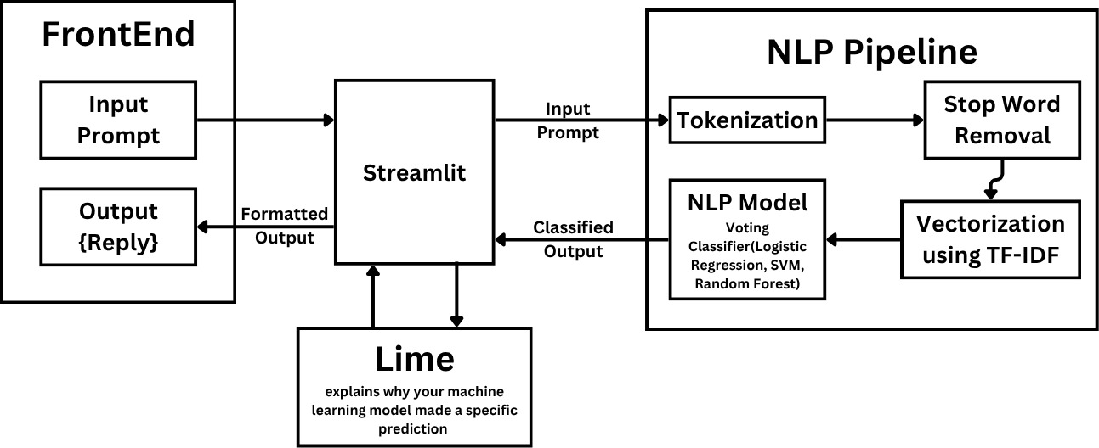
Architecture / Flow Diagram
Fig .Architrcture digram
The above diagram represents the overall architecture of the VerifAI – Fake News Detection System. The process begins at the Front-End, where the user provides an input prompt through the Streamlit interface. This input is passed to the NLP Pipeline, which performs essential text preprocessing steps such as Tokenization, Stop Word Removal, and TF-IDF Vectorization to convert textual data into numerical form. The processed data is then analyzed by the NLP Model, which utilizes a Voting Classifier combining Logistic Regression, SVM, and Random Forest algorithms to classify the news as Real or Fake. The LIME module further explains the reasoning behind the prediction by highlighting the key words that influenced the model’s decision. Finally, the classified and explained output is displayed to the user in a structured and interactive format through the Streamlit interface.

2.3 Text Pre-Processing Steps
2.3.1 Tokenization
Tokenization is the first step in text preprocessing where the raw text is divided into smaller units called tokens (usually words or sentences). In VerifAI, tokenization helps in breaking down news headlines and article content into words, making it easier for the model to analyze textual patterns and relationships.
2.3.2 Stop words removal
Stop words are common words such as “the,” “is,” “in,” “and,” etc., that do not carry significant meaning for classification tasks. These are removed to reduce noise and improve computational efficiency. Removing stop words allows the model to focus on important keywords that help distinguish real and fake news.
2.3.3 TF-IDF Vectorization
Term Frequency–Inverse Document Frequency (TF-IDF) is a crucial feature extraction step used in VerifAI. It converts the preprocessed text into numerical feature vectors by assigning weights to words based on their frequency and importance.
Words that appear frequently in a document but less often across the entire dataset are given higher importance. This representation helps the machine learning model to identify the most relevant words and improve the accuracy of fake news detection.
2.3.4 Any other test preprocessing steps
Other preprocessing techniques applied in VerifAI include:
Lowercasing: All text is converted to lowercase to maintain consistency and avoid duplicate representations of the same word (e.g., “News” and “news”).
Punctuation and Special Character Removal: Punctuations, emojis, and special symbols are removed to simplify text processing.
Stemming and Lemmatization: Words are reduced to their root or base forms to treat variations like “running” and “run” as the same word.

2.4 Model Processing Steps
2.4.1 Main algorithm steps(eg. Tagging, prediction, classification etc)
The VerifAI system uses an ensemble learning approach combining Logistic Regression, Support Vector Machine (SVM), and Random Forest classifiers. The following steps outline the model pipeline:
- Feature Extraction: The cleaned and preprocessed text is transformed into TF-IDF feature vectors.
- Model Training: Each classifier is trained on labeled data to learn distinguishing patterns between fake and real news.
- Voting Classifier: Predictions from all models are combined using a Voting Classifier, which outputs the final classification based on majority voting.
- Prediction: When a user inputs a news headline or paragraph, the system predicts whether it is Real or Fake.
- Explainability (LIME): The Local Interpretable Model-Agnostic Explanations (LIME) module highlights the most influential words that contributed to the model’s prediction, providing transparency and interpretability.
2.5 Software and Hardware Requirements
2.5.1 Software Requirements
- Operating System: Windows 10 or higher / Linux / macOS
- Programming Language: Python 3.8+
- Libraries/Frameworks:
  - scikit-learn
  - pandas
  - numpy
  - nltk
  - streamlit
  - lime
- Development Tools: Jupyter Notebook, VS Code
2.5.2 Hardware Requirements:
- Processor: Intel i5 or above
- RAM: Minimum 8 GB
- Storage: 500 MB for dataset and libraries
- GPU (optional): For faster model training
2.6 Data Used
The dataset used in VerifAI is sourced from publicly available fake news datasets, primarily the Kaggle Fake News Dataset, which contains labeled news headlines and articles categorized as Real or Fake.
- Dataset Size: Approximately 7,800 records
- Features: News title, text content, label (Real/Fake)
- Purpose: Used for training, validation, and testing of the ensemble model to achieve accurate and reliable fake news detection

CHAPTER 3

Results

3.1.1: This is main page for taking an Input

Fig. 3.1: Main Page

3.1.2: After Input predicting if its fake or not (fake)

Fig. 3.2: Prediction (Fake)

3.1.3: After Input predicting if its Real or not (Real)

Fig. 3.3: Prediction (Real)

3.1.4: Explaination about why it is fake.

Fig 3.4: Feature Importance Analysis
3.1.5: Model Evaluation.

Fig 3.5: Model Evaluation

3.1.6: Confusion Matrix and ROC curve.
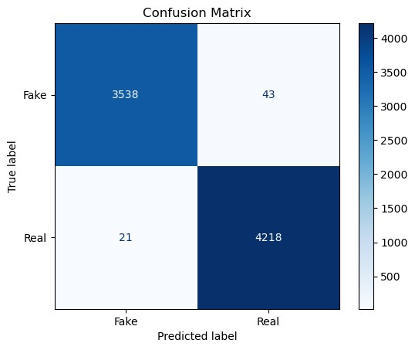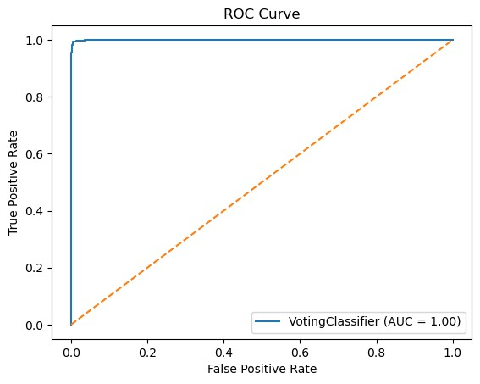Fig 3.6: Confusion Matrix and ROC curve

CHAPTER 4

Conclusion and future work

This project implements a single document text summarization method for English. Many techniques have been developed for summarizing English text(s). The performance of the proposed system may further be improved by improving stemming process, exploring more number of statically and linguistic features like proper noun and applying learning algorithm for effective feature combination. Traditionally, more than one reference summaries are used for evaluating each system generated summary, but in our work, we have used only one reference summary for summary evaluation. In future, we will consider more than one reference summaries for summary evaluation. In future, more features like named entity recognition, cue words, context information, world knowledge etc, can be added to improvise the technique. Also, same technique can be applied on domains other than news and later we can study the effects of various domain characteristics on the suggested features and overall performance of the technique. It can also be extended to work on multiple documents. Also ANN (Artificial Neural Network) based approach can be used for sentence ranking. This method involves training the neural networks to learn the types of sentences that should be included in the summary. This is accomplished by training the network with sentences in several test paragraphs where each sentence is identified as to whether it should be included in the summary or not.

REFERENCES

- Shu, K., Sliva, A., Wang, S., Tang, J., & Liu, H. (2017). Fake News Detection on Social Media: A Data Mining Perspective.
- Kaggle Dataset – Fake News Dataset. https://www.kaggle.com/c/fake-news
- Ribeiro, M. T., Singh, S., & Guestrin, C. (2016). “Why Should I Trust You?” Explaining the Predictions of Any Classifier.
- Scikit-learn Documentation – TF-IDF Vectorizer.
- Streamlit Documentation – Building Interactive Web Apps

